**1.Wi-Fi networks use which access method?**

a.Token ring

b.CSMA/CD

c.CSMA/CW

d.CSMA/CA

**2.A junior network technician needs to set up an access point using 802.11g. What frequency will it use?**

a.Hz

b.2.4 KHz

c.2.4 GHz

d.THz

3.**Which 802.11 standard has the furthest indoor range?**

a.802.11g

b.802.11a

c.802.11n

d.802.11ac

4.**What type of wireless topology would be used when you want to connect two devices directly together in a peer-to-peer relationship?**

a.WDS

b.Ad-hoc mode

c.Infrastructure mode

d.Wireless bridge

**5.Which of these Wi-Fi security standards takes advantage of EAP?**

a.WEP-PSK

b.WEP-Enterprise

c.WPA-PSK

d.WPA2-Enterprise

**6.Which of these Wi-Fi standards does not use a 5 GHz frequency?**

a.802.11b

b.802.11a

c.802.11n

d.802.11ac

**7.You have a wireless network that supports 802.11g, but you have noticed that the network seems to be running at 11 Mbps. What is the most likely cause of this?**

a.EMI

b.Incorrect encryption standard selected

c.Interference from Bluetooth devices

d.You have an 802.11b device on the network

**8.The EAP falls under which standard?**

a.802.1a

b.802.1x

c.802.11b

d.802.11x

Practical:

5.**Using packet tracer setup, the following:**

•A server

•2 Wi-Fi routers connected to the server

•4 desktops connected to each router

•Each network must be able to ping one another

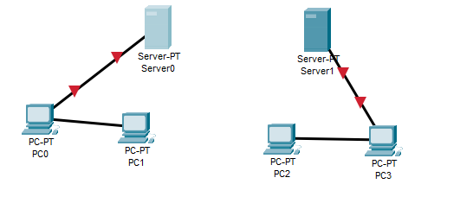

1.**Which of these devices has a routing capability?**

a.Hub

b.Layer 2 switch

c.Layer 3 switch

d.Bridge

2.**Which of these generic routing protocol types will most likely choose a route that goes through the least number of routers?**

a.Path vector

b.Link state

c.Spanning tree

d.Distance vector

**3.Which of these routing protocols is a distance vector protocol?**

a.RIP

b.OSPF

c.IS-IS

d.BGP

4.**Which protocol routes between autonomous systems?**

a.OSPF

b.IS-IS

c.EGP

d.IGRP

5.**Which of these network addresses would represent the default route on a Windows device?**

a.127.0.0.0

b.0.0.0.0

c.255.255.255.255

d.10.20.32.0

6.What feature prevents data from flowing between networks forever?

a.RIP

b.TTL

c.STP

d.OSPF

**7.Assuming only the router selected on the right uses NAT, the translation takes place on the interface with the IP address 72.34.5.6. If the web server at 231.12.15.2 sends data to the PC at 192.168.1.1, what would the source IP address be on the data that the PC receives?**

Choose the correct answer:

a.231.12.15.2

b.231.12.15.1

c.72.34.5.6

d.192.168.1.2

8.**Which function allows for different types of data to be prioritized?**

a.QoS

b.NAT

c.DHCP

d.EIGRP

e.Wireless bridge

Practical:

**6.Using packet tracer setup, the following topologies using a switch and devices:**

**A server  
• 2 Wi-Fi routers connected to the server  
• 4 desktops connected to each router  
• Each network must be able to ping one another**

